Practical no 8
Code:-
feedback=input("Enter Your Feedback:")
print("feedback format report".upper().center(85))

print("\n original feedback:".title())
print(feedback)
print("\n================================================")

print("Feedback Summary".title())
print("total word count:".title(),len(feedback.split()))
print("total character count:".title(),len(feedback))
print("total Spaces count:".title(),feedback.count(" "))
print("total exclamation:".title(),feedback.count("!"))

print("\n===================================================\n")

print("formatted feedback:".lstrip())
print("\n")

print("Uppercase Feedback:",feedback.upper())
print("Lowercase Feedback:",feedback.lower())
print("Title Feedback:",feedback.title())
print("Capitalize Feedback:",feedback.capitalize())
print("Swapcase Feedback:",feedback.swapcase())

print("\n======================================================\n")

print("professional feedback:".capitalize())
print("\n")
print("Words split=",feedback.split())

print("thank you for your valuable feedback".center(85).upper())
Output:-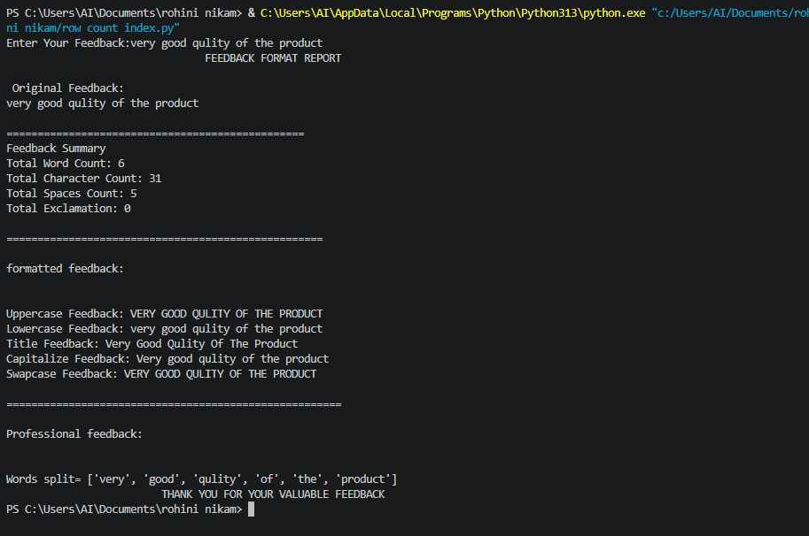
Exercises
Q1.Develop name sanitizer script that read user submitted first and last name .trims accidental trailling space s, and output the full name in clean title case formate.
Code:-
def sanitize_name(first_name, last_name):
"""Trim extra spaces and convert a name to title case."""
first_name = first_name.strip().title()
last_name = last_name.strip().title()

return f"{first_name} {last_name}"

first_name = input("Enter your first name: ")
last_name = input("Enter your last name: ")
print("Clean name:", sanitize_name(first_name, last_name))
Output:-
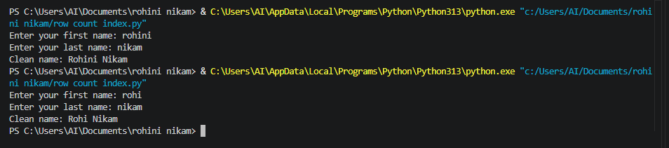

Q 2Build a test moderation filter that identifies specific targets words within a feedback block and replaces them with an asterisk (****)mask.
Code:-
def moderate_text(feedback, target_words):
"""Replace target words with asterisk masks."""
for word in target_words:
feedback = feedback.replace(word, "*" * len(word))
return feedback

feedback = input("Enter your feedback: ")

target_words = ["badword1", "badword2", "badword3"]

filtered_feedback = moderate_text(feedback, target_words)

print("Moderated feedback:", filtered_feedback)

Output:-
